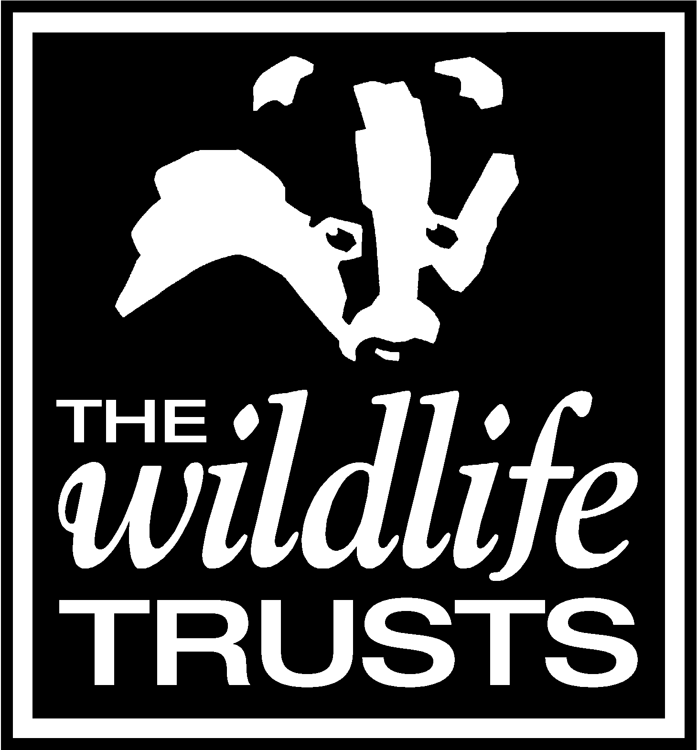



APPLICATION FORM
PLEASE COMPLETE AND RETURN TO:  Robert Hutchinson  Surrey Wildlife Trust  School Lane  Pirbright  Woking  Surrey GU24 OJN  Robert.hutchinson@surreywt.org.uk | APPLICATION FOR THE POST OF:  Assistant Conservation Officer, EPAS
 | CLOSING DATE: 5pm Wednesday 4th June 2025
NOTES:
* COMPLETE IN BLACK PEN OR TYPESCRIPT FOR COPYING PURPOSES
* ANSWER ALL QUESTIONS

1. PERSONAL DETAILS
SURNAME | FORENAMES
ADDRESS  ………………………………………………………………………………………….  ………………………………………………………………………………………….  ………………………………………………………………………………………….  POSTCODE …………………………………………………………... | Tel DAYTIME/mobile  ……………………………………………………………………  Tel HOME  …………………………………………………………………….  E-MAIL

2. PRESENT OR MOST RECENT EMPLOYMENT
EMPLOYER’S NAME AND ADDRESS  ……………………………………………………………………………………….  ……………………………………………………………………………………….  ……………………………………………………………………………………….  …………………………………………………………..………………………….. | POST HELD
 | DATES OF COMMENCEMENT AND LEAVING
 | PERIOD OF NOTICE REQUIRED (if applicable)
Please give a brief description of the duties and responsibilities you carry/carried out plus current/latest salary and salary expectations.

3. PREVIOUS EMPLOYMENT

DATES | EMPLOYER NAME AND ADDRESS | POSITION
4. TRAINING UNDERTAKEN/RELEVANT QUALIFICATIONS
Please give details of any relevant courses you have taken or qualifications you have gained, including education, specialist in-house training, short courses etc. Please also give details of the awarding body and dates of study/qualification.

DESCRIPTION OF COURSE AND DETAILS OF AWARDING BODY |  |  | DATES

5. CRIMINAL RECORD
PLEASE GIVE DETAILS OF ANY UNSPENT CRIMINAL OFFENCES IN ACCORDANCE WITH THE REHABILITATION OF OFFENDERS ACT (EXCEPTIONS) ORDER 1975 AND/OR (NORTHERN IRELAND) 1979.

6. REFERENCES
Please give details of two people, not related to you, who may be approached for references as to your suitability for the post.
The first should be your present employer or your last employer if not currently employed. The second should be someone who is able to comment on your work abilities.

(1) NAME………………………………………… (2) NAME………………………………………….

POSITION……………………………………….. POSITION…………………………………….…..

ADDRESS ……………………………………… ADDRESS………………………………………..

……………………………………………………. ……………………………………………………..

…………………………………………………… ……………………………………………………..

……………………………………………………. ……………………………………………………..

POSTCODE…………………………………….. POSTCODE……………………………………..

TELEPHONE NO………………………………. TELEPHONE NO………………………………..

E-MAIL …………………………………………. E-MAIL ……………………………………………

MAY WE CONTACT YOUR REFERENCES BEFORE YOUR INTERVIEW? 1. YES NO

2. YES NO

7. ADDITIONAL INFORMATION
Having read the Job Profile, please include details of relevant experience, knowledge and skills plus your personal qualities which make you suitable for the position of Assistant Conservation Officer, EPAS.
Continue on back page and attach one additional sheet if necessary.

PRINTED ON RECYCLED PAPER

I CONFIRM THAT TO THE BEST OF MY KNOWLEDGE THE INFORMATION GIVEN ON THIS FORM IS CORRECT. I CONFIRM THAT I AM FIT AND ABLE TO UNDERTAKE THE POST OF Assistant Conservation Officer.

SIGNATURE ……………………………………………………… DATE ………………………………………..
For monitoring purposes only – please tell us where you saw this post advertised.

