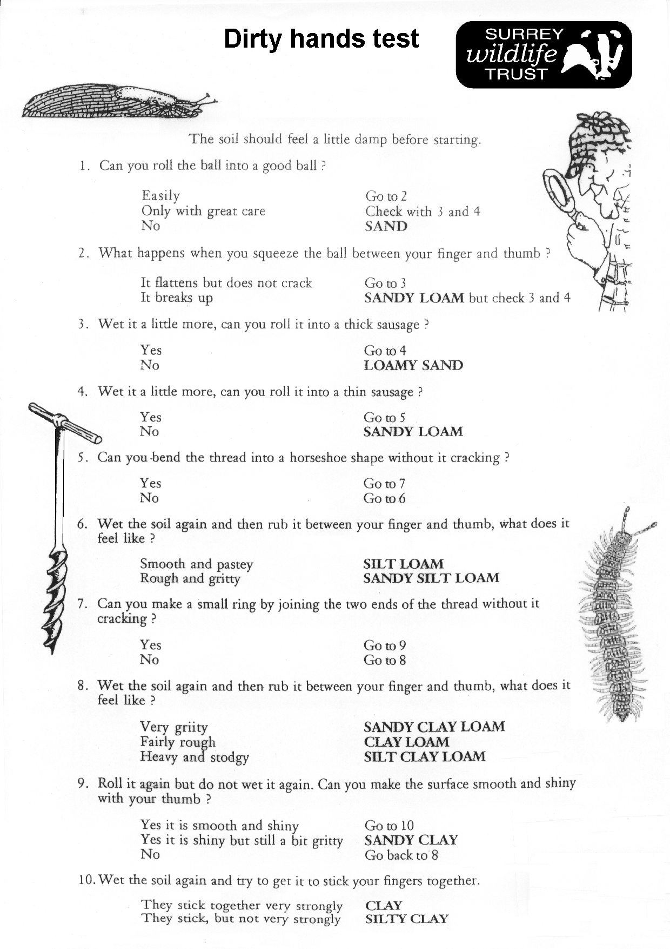
Can you roll the soil into a good ball?
Can you roll the soil into a good ball?
